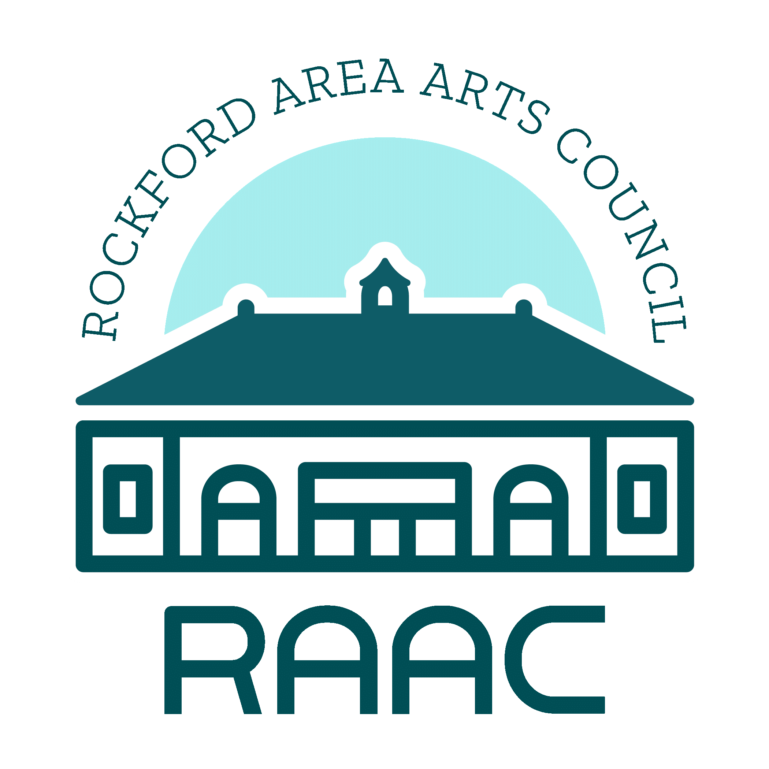

**815 Community Response Team—Arts COVID-Response Fund**

The funds for this grant process are made possible by the 815 Community Response Team.

The 815 Community Response Team (815CRT) was convened by the Northern Illinois Center for Nonprofit Excellence (NICNE) in March 2020 to help ensure nonprofits in northern Illinois (Boone, Ogle, Stephenson, and Winnebago Counties) and the people they serve are supported during and after the COVID-19 pandemic. 815CRT is made up of public and private funders and other partners, working with the nonprofit sector to identify needs and to make funds available for both immediate emergency needs as well as needs that will emerge in the near and not-so-near future. [www.815CRT.org](http://www.815CRT.org)

Current Coalition partners include: Community Foundation of Northern Illinois, Kjellstrom Family Foundation, Northern Illinois Center for Nonprofit Excellence, Rockford Area Convention and Visitors Bureau, Transform Rockford, United Way of Rock River Valley.

Purpose of 815CRT-ART

**The purpose of the 815CRT-ART COVID-Response Fund is to provide immediate operational relief to arts and culture organizations** to mitigate the impact of the COVID-19 pandemic. This is a competitive grant application process and resources are limited. The 815CRT-ART has over $70,000 available for awards, with a goal to provide substantive funding to each recipient; the maximum award per organization is $10,000.

**Applicant considerations for 815CRT-ART funding:**

* Describe how the pandemic has impacted your organization’s ability to effectively operate, e.g.:
  + Shuttered venues
  + Elimination of ticketed events or performances
  + Staff reductions
  + Deferrals of repairs and/or planned maintenance
* Discuss strategies employed by your organization to maintain or even build capacity during this time, particularly as it relates to supporting other artists and the arts community as a whole. In addition to providing immediate operational relief, 815CRT-ART funds can be used to leverage other outside funding, create or sustain better systems or processes, build partnerships or efficiencies, and/or enhance knowledge for improved operations.
  + If two or more organizations wish to submit a collaborative proposal, fund requests could average $10,000 per partner organization.

**Eligibility for Grant Allocations**

In order to be eligible for a grant allocation from the 815CRT-ART COVID-Response Fund, nonprofit agencies must:

* Be a 501(c)(3) Organization
* Be in operation and provide arts and/or cultural services in Boone, Winnebago, Ogle or Stephenson counties for at least three years
* Have an active, local Board of Directors comprised of unpaid volunteers who meet, at least, quarterly
* Maintain an annual operating budget
* Agree to the 815CRT-ART Memorandum of Understanding
* Comply in a timely manner to a request for additional information

**Ineligibility for Grant Allocations**

Agencies that provide programs or services described below are ineligible for funding:

* Provide programs or services limited solely to the members of a particular religious group. A program run by an agency with a religious affiliation may be granted funds, but only if the program is not religion-based and grant allocation funds are clearly not used for religious activities.

Review and modification of these standards may be made at the discretion and approval of the 815CRT-ART Steering Committee.

**Grant Application Form**

1. **Organizational Information**

Organization ________________________________________________________________

Address ­­­­­­____________________________________________________________________

Phone ________________________________Fax __________________________________

E-mail _____________________________________________________________________

Executive Director ____________________________________________________________

Contact Person (if other than Executive Director) ____________________________________

Board Chair _________________________________________________________________

Organization Mission __________________________________________________________

___________________________________________________________________________

___________________________________________________________________________

Amount of Request __________________________________________________________

________________________ ________________________________

Signature of Executive Director Date of Application

1. **Grant Narrative**

Please consider the 815CRT-ART COVID-Response Fund priorities listed on the first page of this document along with the following bullet points. In a maximum of two (2) pages, describe how the 815CRT-ART will assist your organization, in relationship to the impact of COVID-19, using the following prompts:

* How have the operations at your organization been affected by the COVID-19 pandemic? Describe the loss of venue(s), elimination of revenue from events, staff reductions, deferred repairs or maintenance for your facility, and so on.
* Describe how the 815CRT-ART funding will allow your organization to positively affect other artists, organizations, and the Greater Rockford Community.

1. **Grant Deadlines**
   1. The deadline for the 815CRT-ART grant funding is April 9, 2021.
   2. Allocations will be released on May 7, 2021.
   3. Final Report due December 1, 2021.
2. **Application Submittal**Scan and email a completed copy of this packet, your grant narrative, and a copy of your 501(c)(3) exemption letter to [info@artsforeveryone.com](mailto:info@artsforeveryone.com) or send a hard copy to the Rockford Area Arts Council, 713 E. State St. Rockford, IL. 61104. Contact Mary McNamara Bernsten at Rockford Area Arts Council at [mary@artsforeveryone.com](mailto:mary@artsforeveryone.com) or 815-963-6765 with any questions or concerns.

*The 815 Community Response Team is a partnership of the Community Foundation of Northern Illinois, The Kjellstrom Family Foundation, the Northern Illinois Center for Nonprofit Excellence, and United Way of Rock River Valley; the Rockford Area Arts Council is collaborating with 815CRT for this opportunity.*

